WASHINGTON PARISH COUNCIL MEETING

MINUTES of the monthly meeting of Washington Parish Council held on Monday 7th July 2025 in the Washington Village Hall (Doré Room) School Lane, Washington RH20 4AP

PRESENT: Cllr A Dillaway, Cllr B Hanvey, Cllr O. Jupp, Cllr T Keech, Cllr M. Shaw and Cllr A Lisher (Chairman).

IN ATTENDANCE: Cllr P Marshall (WSCC), Cllr E. Beard (HDC), Cllr J Grech (HDC) and Cllr C Fisher (HDC).

ALSO: Ms Z. Savill (Clerk to the Council). There were two members of the public.

ABSENT: Cllrs Brookes and Thomas

Cllr Lisher (Chairman) opened the meeting at 7:00pm

FC/25/7/1 Apologies for Absence
The Council RESOLVED to accept apologies for absence from Cllrs Brookes and Thomas.

FC/25/7/2 Declaration of Members’ Interests.
None declared as defined under the Localism Act 2011 and the Council’s Code of Conduct.
or requests for a dispensation.

FC/25/7/3. Minutes of the last Full Council meeting
The Council RESOLVED to APPROVE the minutes of the Full Council Meeting held on 2nd June 2025
and were duly signed by the Chairman after the meeting.

FC/25/7/4. Public Forum
The applicant for Plot 6 on the Council’s allotment answered questions from members and
explained his proposals for keeping chickens.

Cllr Lisher thanked him and explained that his application would be considered during a closed
session at the end of the meeting.

The applicant thanked the Council and left the meeting.

FC/25/7/5. Reports from County and District Councillors

HDC Reports

Cllr Fisher reported the following:

Work is ongoing ,including engagement with HDC’s Environmental Health Officers, to
persuade the Washington Kia dealership to park their vehicles more considerately.

Residents are invited to participate in HDC’s next Full Council meeting at the Steyning Centre on
16th July.

HDC is seeking parish feedback before it responds to the Government’s consultation for reforms
of Local Authority Planning Committees. The deadline is 23rd July. Cllr Fisher, Cllr Beard and Cllr
Grech will also be responding, and raising their concerns about the changes, especially in
the reduction of committee membership. Cllr Fisher will circulate consultation details after the
meeting for the Council/members to make their own response.

WSCC Reports

Cllr Marshall reported the following:

He has met with St Mary’s School to discuss safer walking routes for children after a
recent incident on the A283 at Washington .Cllr Beard will join the next meeting to
review which routes are being used before the Parish Council is consulted about the
the possibility of using a route on the Recreation Ground.

Cllr Marshall reported on a consultation process to begin later this month, on potential
changes to local government structure, including the possibility of creating a single unitary
authority for the County. Town and Parish Councils, along with the public and other stakeholders,
will be consulted before final proposals are submitted to the Government in September.

Cllr Lisher thanked the County and District Councillors for their reports before they left the
meeting.

FC/25/6/6. Co-option
It was noted that there were no applications received for co-option to the vacancies on the
Council. To be deferred to the next meeting.

FC/25/7/7 Co-option to the Standing Committees
The Council welcomed Cllr Shaw to her first meeting since her-recent co-option. It was
RESOLVED that Cllr Shaw serve on the Personnel Committee and the Planning & Transport
committee and she duly accepted.

FC/25/7/8 Planning applications, Decisions, Appeals and Compliance Matters

SDNP/25/02421/HOUS - School House School Lane, Washington, West Sussex, RH20 4AP
To replace the existing single-glazed wooden framed windows with new uPVC framed window of
the exact same size, style and position as the existing windows. They will be white frames and
have horizontal cross bars to match the existing style.

The Council reviewed the application proposals for the property which is within the village
conservation area and noted that the adjoining school building has UPVC windows.

Following a discussion the Council RESOLVED to make NO OBJECTION if the proposed
windows are visually compatible in all respects and match the existing styles.

DC/25/0895 - Cadrona Hampers Lane Storrington West Sussex
Construction of detached dwelling and detached carport/garage building with vehicle access from
Hampers Lane.

The Council discussed this application and RESOLVED to make an OBJECTION with
one abstention. Members agreed that the proposed access at this junction of Hampers Lane,
which is also a public right of way, with the A283 and quarry access, is very dangerous.
It was further agreed to comment that the proposal represents infill development, contrary to the
Parish Council’s adopted Heath Common Design Statement which seeks to protect the unique
character of this area.

DC/25/0470 - Fernbank Hampers Lane Storrington West Sussex
Erection of side and rear extensions, first floor roof extension and detached garage with
accommodation above.

The Council discussed this application and RESOLVED not to add to their comments
already made on 30th April 2025.

FC/23/7/9 Appeals Lodged and Decided
Cllr Lisher reported that the appeal for 240 houses at the Thakeham mushroom site had been
refused. Formal notification of the decision is anticipated from the planning inspectorate.

FC/25/7/10 Compliance Matters
None reported.

FC/26/7/11 Actions and matters arising
None reported.

FC/25/7//12 Committees
The Council RESOLVED to note the draft minutes of the
Planning & Transport Committee Meeting and the OSRA Committee Meeting both held on
16th June 2025 and one recommendation from the OSRA meeting to be ratified under the next
item of business.

FC/25/7/13 Washington Recreation Ground Charity: MUGA LED lighting proposals
The Council considered a recommendation from the OSRA Committee at its meeting on
16th June last to ratify approval of the revised MUGA LED lighting, and engagement of a planning
consultant.

Supporting papers were previously circulated, and the Council RESOLVED to ratify approval of
the following recommendations:

- To agree quotation from Architekton Architects Ltd of £ 1,005 plus £95 per hour for any additional work by prior agreement with the Council, for services required for a planning application to the SDNPA for replacement lighting.

- To agree a quotation from Case Electrical Ltd of £4,737.94 for supply and installation of the Harlock Cour floodlighting, subject to the specification being agreed by the SDNPA.

FC/25/7/14 Washington Recreation Ground Charity
The Council RESOLVED to agree the quotation of £695 from Delwood for repairs to the
Rota Roka, Ryan Tower slide, picnic table and two benches in the Play Area and the grounds.

FC/25/7/15 Reports from Members representing the Council on Outside Bodes
The Council noted the following reports:

HDC Neighbourhood Planning Workshop for Parishes on 19th June 2025
Cllr Keech gave an overview of the workshop he attended with Cllr Lisher. He explained
there is general uncertainty about the future of the Local Plan and Neighbourhood Plans
due to the Government’s recent strategic planning reforms and what might be
coming down the line from local government devolution. HDC was still exploring its options
after the failed Local Plan and how to allocate the increased housing targets which may be
proportionately across the district. More would become known later this year when new
regulations for local plan-making are anticipated, but in the meantime it would not be possible
to update the parish’s joint Neighbourhood plan until the Local Plan is examined..

A slide presentation of the workshop was previously circulated on the Council’s One Drive at:
Neighbourhood Plan Workshop .

Storrington & Sullington and Washington Neighbourhood Plan (SSWNP)Review
Keech reiterated the difficulty of progressing the review of the neighbourhood plan,
and without knowing a goal, it was effectively frozen. It was noted that there were
plans for the Steering Group to meet to discuss next steps following the Government’s
recent announcement to withdraw of neighbourhood plan funding.

HALC Meeting which included HDC presentations on LGD on 19th June 2025 (evening)
It was noted that the meeting minutes with presentations on LGD and the Government’s
Planning Committee reforms consultation had been distributed to members.

FC/25/7/16 Urgent Matters
None reported

FC/25/7/17 Delegated decisions
The Council ratified the delegated decisions to approve the following quotations and payments:

4.6.2025: £110 quotation for replacement of the basketball nets by Mr Collis
11.6.2025: £30 quotation removing weeds on Play Area safety surfacing by Sussex Land Services
29.6.2025: £1,211.69 payment of the Council insurance premium – quotation agreed APCM
12th May 2025.

FC/25/7/18 Payments, Income and Bank Reconciliations
The Council RESOLVED to approve the following payments of invoices for the total sum
of £4,664.20:
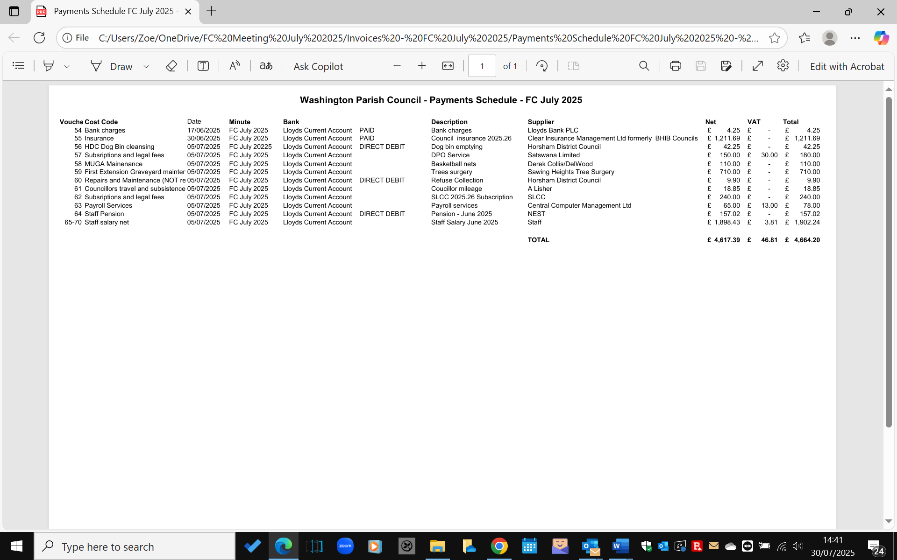

The Council further RESOLVED to approve payment of £1,640 late presentation invoice
from Mr Morley for tree works, quotation reference: 649.

Bank Transfer:
The Council RESOLVED to transfer £3,000 to the Nationwide 35-day savings account if there are
sufficient funds and subject to the banks mandate approval of the additional two signatories.

Bank Reconciliation:
The Council RESOLVED to note the £20,339.93 reconciled balance on the Lloyds Community
Account for June 2025.

Income
The Council RESOLVED to note that no income was received since the last meeting.

FC/25/7/19 Budget Position for operating costs
Copies of the Council’s flexed first quarter 2025.26 budget report were distributed. Following
a discussion, the Council RESOLVED to note the report. It was further noted that Cllr Keech
would work with Clerk on aligning the net and gross figures for salary and employer
contributions with budget figures on the Council’s accounting program, as agreed at the
Finance Committee meeting in January.

FC/25/6/20 Clerk’s Report
The Council noted the following:

- Employment law changes
WSALC’s summary of the key changes to Employment Law from April 2025

- Lloyds community account
Statements and invoices on the Council’s community account will be paper-free from
26th August 2026 and only available online.

- Nationwide business savings account review
The Chairman and the Clerk are responding to the bank’s request to update signatory
information on the account before the 23rd July deadline.

- Non-financial S106 activities
Further to an email received from HDC on 10th June, a group of HDC Councillors are
gathering feedback on non- financial S106 activities across the district. Members were
invited to submit comments to HDC before the 11th July deadline.

Freedom of Information (FOI)
The Council received(25th June 2025) an FOI request to know its involvement with the
Storrington Traffic Group’s 20mph campaign. The Clerk had replied (30the June 2025)
that the Council has had no formal interaction with the group and does not hold any
personal details of personal involvement by Councillors. A follow-up request
from the same member the public is to be similarly addressed, confirming the
members’ compliance with relevant legislation and the Council’s Code of Conduct.
.
FC/25/7/21 Local Government Devolution: Community Asset Transfer
A list of properties owned in the parish by HDC were previously circulated to the Council
together with supporting information from HDC provided at the recent HALC meeting on 19th
June.

The Clerk reported that HDC has invited the parish to identify any discrepancies in the lists
should the Council consider taking over any under HDC’s emerging Community Asset Transfer
Policy.

The Council reviewed the list, noting errors and a lack of clarity that made some
assets hard to identify. Concerns were raised about the financial risks and burdens of
taking on HDC’s assets, especially given incomplete information.

Following a discussion, the Council RESOLVED unanimously not to engage further with HDC on
updating the list or to express an interest in transfer of assets at this time.

FC/25/7/22 Correspondence
The Council noted the following correspondence received and previously distributed:

- Parish Briefings from the Highways Authority at: Highways Authority Parish Briefings June 2025

- NALC Chief Executive Bulletin 26th June 2025 at: Chief executive's bulletin - 26 June 2025_files

- CPRE Newsletter June 2025 at: CPRE June 2025 Newsletter

- Highways Transport and Planning News Updates June 2025 at: Highways Transport & Planning June 2025 News Updates

- ATM Tampering [#464263807] view update at: Sussex Alerts ATM Tampering

FC/25/7/23 Chairman’s announcements
None

FC/25/7/24 Dates and Times of the next meetings
Planning & Transport Committee: Monday 21st July 7:00pm
Finance Committee: Monday 21st July 7:30pm
OSRA Committee: Monday 21st July 8:00pm
Parish Council Meeting: Monday 4th August 2025, 7:30pm

FC/25/7/25 Confidential Session
The Council RESOLVED that under the Public Bodies (Admissions to Meetings) Act 1960, the
public and representatives of the press and broadcast media be excluded from the meeting
during consideration of the following items of business as publication would be prejudicial to the
public interest because of the confidential nature of the business to be transacted.

FC/25/7/26 Application for Plot 6 on the Council Allotment
The Council noted that this item had been deferred from the OSRA Committee Meeting
on 16th June last, pending detailed proposals from the applicant for Plot 6. A copy of these
were distributed prior to the meeting.

The Council discussed these, together with comments from the Applicant earlier in the meeting
and feedback from the Stewards. It was RESOLVED to approve the tenancy for Plot 6 and
proposals subject to the following conditions:

- The signed tenancy terms and payment of rent;
- The hens to be to be kept to the right of the plot so as not to be a nuisance to
neighbouring plots;
- the shed to be no larger than the shed permitted for Plot 9b and the design to
be first approved by the Council/OSRA Committee;
- The polytunnel not to be larger than the one on Plot 8.

It was further agreed to notify the Stewards and the new Tenant of Plot 6 of the Council’s
Intention In the annual review to regularise future infrastructure on plots and include terms on
the keeping of poultry.

FC/25/7/27 Washington Recreation Ground Charity: Rampion 2 legal matters
To Consider a quotation for the legal work required on the terms of access to the Washington
Recreation Ground/Village Green for the Rampion 2 underground cable.

The Council discussed the estimated legal fees of £4,500 plus VAT for Moore and Barlow LLP
to handle its Rampion legal matters, with flexibility for increases if additional work is justified,
and with the Council’s prior approval.

This Council RESOLVED to agree engagement of the solicitor subject to agreement of their
contract terms and RED’s (Rampion Extension Development Ltd) agreement to meet legal costs
directly. Clerk to follow up with RED and to contact the Solicitor for their terms of engagement
for consideration of formal acceptance at next Council meeting.

There being no further business to transact, the meeting was closed at 9:25pm.

Signed……………………………………………..

Dated………………………………………………

Glossary of acronyms

AIRS Action in Rural Sussex
AGAR Annual Governance and Accountability Return
CIL Community Infrastructure Levy
CPRE Council for the Protection of Rural England
CSW Community Speed Watch
DCO Development Consent Order
DPO Data Protection Officer
HALC Horsham Association of Local Councils
HDC Horsham District Council
HDPF Horsham District Planning Framework
HAMSVA Horsham and Mid Sussex Voluntary Association
ICO Information Commission Office
LGD: Local Government Devolution
LGR: Local Government Re-organisation
LGS Local Green Space
NALC National Association of Local Councils
SSWNP: Storrington & Sullington and Washington Neighbourhood Plan
NPPF National Planning Policy Framework
PCC Police Crime Commissioner
PINS Planning Inspectorate
PROW Public Rights of Way
SDNPA South Downs National Park Authority
SDNP South Downs National Park
SHELAA Strategic Housing Economic Land Availability Assessment
SID Speed Indicator Device
SLCC Society of Local Council Clerks
TPO Tree Preservation Order
TRO Traffic Regulation Order
TTRO Temporary Traffic Regulation Order
VAS Vehicle Activation Device
WPC Washington Parish Council
WRGC Washington Recreation Ground Charity
WSALC West Sussex Association of Local Councils
WSCC West Sussex County Council

